QUEST 1

WAP to calculate the fare for a railway journey depending on the following conditions.

|  |  |  |
| --- | --- | --- |
| **Age** | **Distance [ in Kms ]** | **Fare** |
| Below 10 | Below 50 | 5 |
|  | 51 -100 | 10 |
|  | Above 100 | 15 |
| 11-50 | Below 50 | 10 |
|  | 51-100 | 15 |
|  | Above 100 | 20 |
| Above50 | Below 50 | 15 |
|  | 51-100 | 20 |
|  | Above100 | 25 |

#include<stdio.h>

#include<conio.h>

void main()

{

int age,dis;

clrscr();

printf("enter the age");

scanf("%d",&age);

if(age<10)

{

printf("enter the distance");

scanf("%d",&dis);

if(dis<50)

{

printf("the fare is 5");

}

else if(dis>=50&&dis<=100)

{

printf("the fare is 10");

}

else

printf("the fare is 15");

}

else if(age>=11&&age<=50)

{

printf("enter the distance in km");

scanf("%d",&dis);

if(dist<50)

{

printf("the fare is 10");

}

else if(dis>=50&&dis<=100)

{

printf("the fare is 15");

}

else

printf("the fare is 20");

}

else

{

printf("enter the distance in km");

scanf("%d",&dis);

if(dis<50)

{

printf("the fare is 15");

}

else if(dis>=50&&dis<=100)

{

printf("the fare is 20");

}

else

printf("the fare is 25");

}

getch();

}

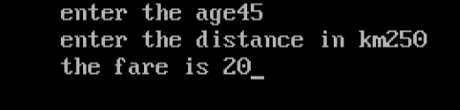

QUEST 2

A cloth showroom has announced the following festival discounts on purchase of items:

|  |  |  |
| --- | --- | --- |
| Amount of purchase | Discount in % | |
|  | Mill Cloth | Handloom items |
| Less than Rs. 1000 | 2% | 5% |
| Rs 1000 to Rs. 5000 | 20% | 25% |
| Rs. 5001 to Rs.10000 | 40% | 50% |
| Above 10000 | 50% | 60% |

WAP to compute the net amount paid by the customer. Assume all required values to be inputted by the user.

#include <stdio.h>

#include <conio.h>

void main()

{

long int a,t;

float d;

clrscr();

printf ("Enter the amount of purchase : ");

scanf ("%ld",&a);

printf ("Enter 1 for Mill Cloth and 2 for Handloom Items : ");

scanf ("%ld",&t);

if (t=1)

{

if (a<1000)

{

d=0.02;

}

else if (a>=1000 && a<=5000)

{

d=0.2;

}

else if (a>=5000 && a<=10000)

{

d=0.4;

}

else

{

d=0.5;

}

}

if (t=2)

{

if (a<1000)

{

d=0.05;

}

else if (a>=1000 && a<=5000)

{

d=0.25;

}

else if (a>=5000 && a<=10000)

{

d=0.5;

}

else

{

d=0.6;

}

}

a=a-(a*d);

printf ("Your total payable amount is : Rs. %ld.",a);

getch();

}

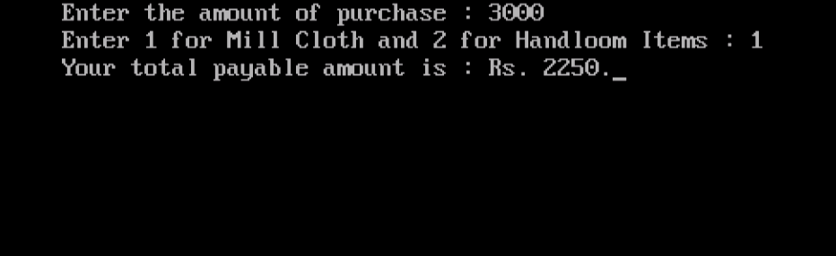

QUEST3

WAP to print whether the number is prime or not

#include<stdio.h>

#include<conio.h>

int main()

{

int n,i,c=0;

clrscr();

printf("enter the number");

scanf("%d",&n) ;

for (i=1;i<=n;i++)

if (n%i==0)

{

c++;

}

if(c==2)

{

printf(" is a prime number");}

else

{

printf(" is not a prime number ");

}

getch();

return 0;

}

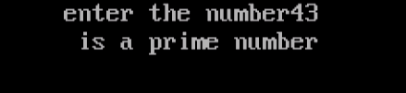

QUEST4

WAP to enter the number and check whether it is strong number or not.

#include<stdio.h>

#include<conio.h>

int main()

{

int n,i;

int fact,rem;

int sum=0;

int temp=n;

clrscr();

printf("enter the number ");

scanf("%d",&n);

while(n)

{

i=1,fact=1;

rem=n%10;

while(i<=rem)

{

fact=fact*i;

i++;

}

sum=sum+fact;

n=n/10;

}

if(sum==temp)

printf(" is a strong number");

else

printf(" is a not strong number");

getch();

return 0;

}

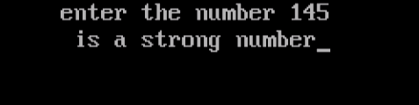

QUEST 5

WAP to print all the amstrong number between 1-1000

#include<stdio.h>

#include<conio.h>

int main()

{

int i,num,x,sum=0,mem;

for(i=1;i<=1000;i++)

{

sum=0;

num=i;

mem=num;

while(num>0)

{

x=num%10;

num=num/10;

sum=sum+x*x*x;

}

if(sum==mem)

{

printf("%d\n",mem);

}

}

getch();

return 0;

}

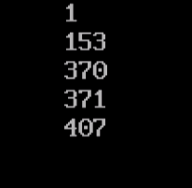

QUEST 6

WAP to print the series of number 1,11,111,1111 ………..

#include <stdio.h>

#include <conio.h>

void main()

{

int n,i;

long sum=0;

long int t=1;

clrscr();

printf("Input the number of terms : ");

scanf("%d",&n);

for(i=1;i<=n;i++)

{

printf("%ld",t);

if (i<n)

{

printf("+");

}

sum=sum+t;

t=(t*10)+1;

}

printf("=%ld",sum);

getch();

}

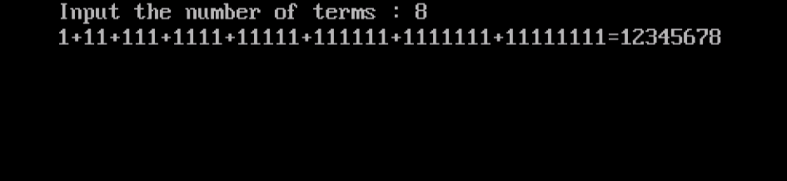

QUEST7

WAP to print the sum of the series 1!+2!+3!..............

#include <stdio.h>

#include <conio.h>

void main()

{

int n,i,j;

long int f,sum=0;

clrscr();

printf("Enter the number of terms : ");

scanf("%d",&n);

for(i=1;i<=n;i++)

{

f=1;

printf("%ld!",i);

if (i<n)

{

printf("+");

}

for (j=1;j<=i;j++)

{

f=f*j;

}

sum=sum+f;

}

printf("=%ld",sum);

getch();

}

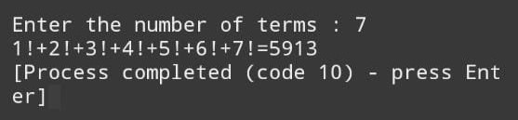

QUEST 8

WAP to print the following pattern

*

***

*****

*******

*********

123454321

1234321

12321

121

1

#include <stdio.h>

#include <conio.h>

void main() {

int i, j, s, r, k = 0;

clrscr();

printf("Enter even number of rows : ");

scanf("%d", &r);

r=r/2;

printf("\n");

for (i = 1; i <= r; ++i, k = 0) {

for (s= 1; s <= r - i; s++) {

printf(" ");

}

while (k < 2 * i - 1) {

printf("*");

k++;

}

printf("\n");

}

for(i=0; i<=r; i++)

{

for(s=0; s<i; s++)

printf(" ") ;

for(j=1; j<=(r-i); j++)

printf("%d",j);

for(j=r-i-1; j>=1; j--)

printf("%d",j);

printf("\n");

}

getch();

}

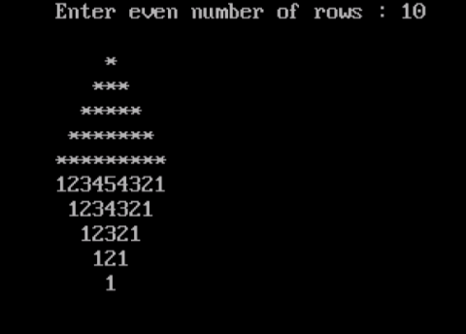

QUEST9

WAP to read and print an book’s Details using Structure - In this program, we will read book’s details like name, author,pages,price using structure and then print the entered values.

#include<stdio.h>

#include<conio.h>

#include<string.h>

#define SIZE 20

struct bookdetail

{

char name[20];

char author[20];

int pages;

float price;

};

void output(struct bookdetail v[],int n);

void main()

{

struct bookdetail b[SIZE];

int n,i;

clrscr();

printf("Enter the Numbers of Books:");

scanf("%d",&n);

printf("\n");

for(i=0;i<n;i++)

{

printf("\t=:Book %d Detail:=\n",i+1);

printf("\nEnter the Book Name:\n");

scanf("%s",b[i].name);

printf("Enter the Author of Book:\n");

scanf("%s",b[i].author);

printf("Enter the Pages of Book:\n");

scanf("%d",&b[i].pages);

printf("Enter the Price of Book:\n");

scanf("%f",&b[i].price);

}

output(b,n);

getch();

}

void output(struct bookdetail v[],int n)

{

int i,t=1;

for(i=0;i<n;i++,t++)

{

printf("\n");

printf("Book No.%d\n",t);

printf("\t\tBook %d Name is=%s \n",t,v[i].name);

printf("\t\tBook %d Author is=%s \n",t,v[i].author);

printf("\t\tBook %d Pages is=%d \n",t,v[i].pages);

printf("\t\tBook %d Price is=%f \n",t,v[i].price);

printf("\n");

}

}

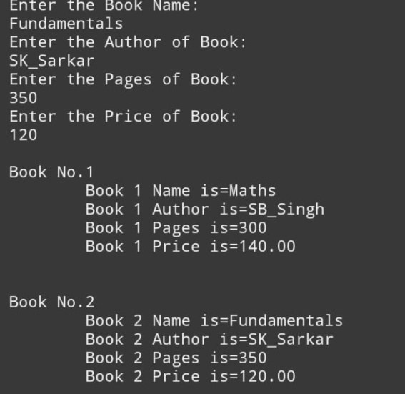

QUEST10

WAP a menu driven program to input an 1-D array and perform following functions

Find the sum of elements of array

To print alternate elements of the array

To print the diffrenece between the first and last element of array

To check the number is palindrome or not

#include<stdio.h>

#include<conio.h>

//declaring functions

void sum(int x[5]);

void alternate(int x[5]);

void diff(int x[5]);

void pall(int x[5]);

void main(){

int i,num[5],pick;

clrscr();

printf("Enter 6 numbers:\n");

for(i=0;i<=5;i++){

scanf("%d",&num[i]);

}

printf("\n");

printf("Enter 1 to print sum of numbers\n");

printf("Enter 2 to print alternate elements\n");

printf("Enter 3 to print difference between 1st and last elemnt\n");

printf("Enter 4 to print the pallindrome numbers if found any\n");

printf("Choice:");

scanf("%d",&pick);

printf("\n");

switch(pick){

case 1:sum(num);

break;

case 2:alternate(num);

break;

case 3:diff(num);

break;

case 4:pall(num);

break;

default:printf("Invalid Input");

}

getch();

}

//defining the sum function

void sum(int x[5]){

int i,sum=0;

for(i=0;i<=5;i++){

sum=sum + x[i];

}

printf("Sum of all no: %d",sum);

getch();

}

//defining the alternate function

void alternate(int x[5]){

int i;

printf("Alternate numbers:");

for(i=0;i<=5;i++){

if(i%2==0){

printf("%d ",x[i]);

}

}

}

//defining the diff function

void diff(int x[5]){

printf("Difference of first and last element: %d",x[5]-x[0]);

}

//defining the pallindrome function

void pall(int x[5]){

int i,rem,rev,a;

for(i=0;i<=5;i++){

a=x[i];

rev=0;

while(a>0){

rem=a%10;

rev=rev*10+rem;

a=a/10;

}

//check if pallindrome

if(rev==x[i]){

printf("%d is pallindrome\n",x[i]);

}

}

}

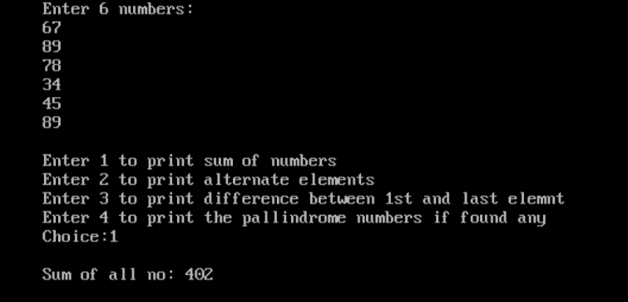 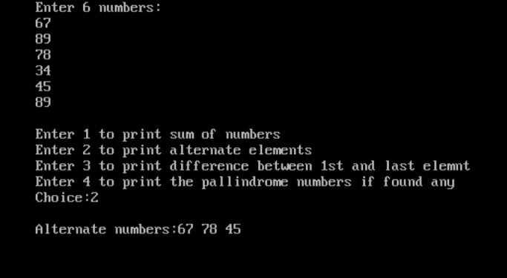

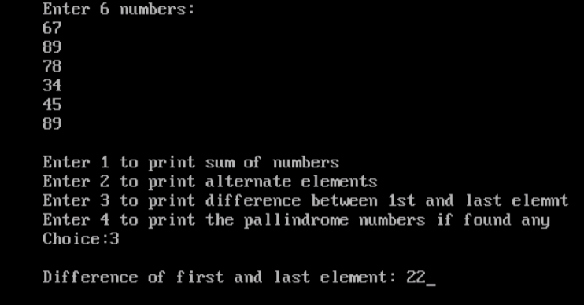 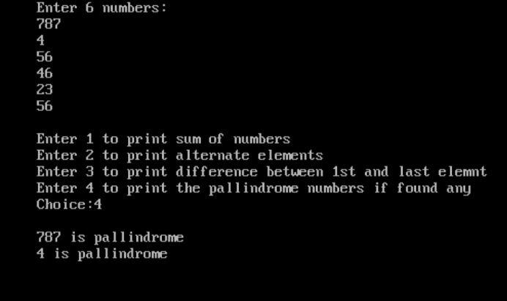

QUEST11

WAP to read 2-D array and perform following actions

Find he sum of two arrays

Find the difference between first and last element

Find the sum of diagonals

Find the transpose of each matrix

#include<stdio.h>

#include<conio.h>

void main(){

int ar[3][3];

int arr[3][3];

int a,b,c,d,e,f;

char g;

clrscr();

for(a=0;a<3;a++){

for(b=0;b<3;b++){

printf("\n Enter %d,%d element of 1st matrix=",a+1,b+1);

scanf("%d",&ar[a][b]);

printf("\nEnter %d,%d element of 2nd matrix=",a+1,b+1);

scanf("%d",&arr[a][b]);

}}

label:

printf("\n Enter 0 for sum of matrix\n Enter 1 for subtraction\n Enter 2 for Multiplication \n Enter 3 for sum of diagonals \n Enter 4 for Transpose of each matrix=");

scanf("%d",&c);

for(d=0;d<3;d++){

printf("\n");

for(e=0;e<3;e++){

if(c==0){

printf("%d\t",ar[d][e]+arr[d][e]);}

else if(c==1)

printf("%d\t",ar[d][e]-arr[d][e]);

else if(c==2){

f=(ar[d][0]*arr[0][e]+ar[d][1]*arr[1][e]+ar[d][2]*arr[2][e]);

printf("%d\t",f);}

else if(c==3){

if(d==e)

printf("%d",ar[d][e]+arr[d][e]);

}

else if(c==4){

printf("%d\t",ar[d][e]);

printf("%d\t",arr[d][e]);}

else

printf("Invalid choice");

}}

printf("\nDo you want to run again y/n");

scanf("%c",&g);

if(g=='y')

goto label;

getch();}

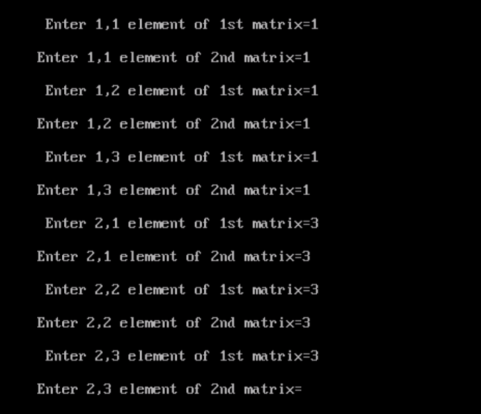 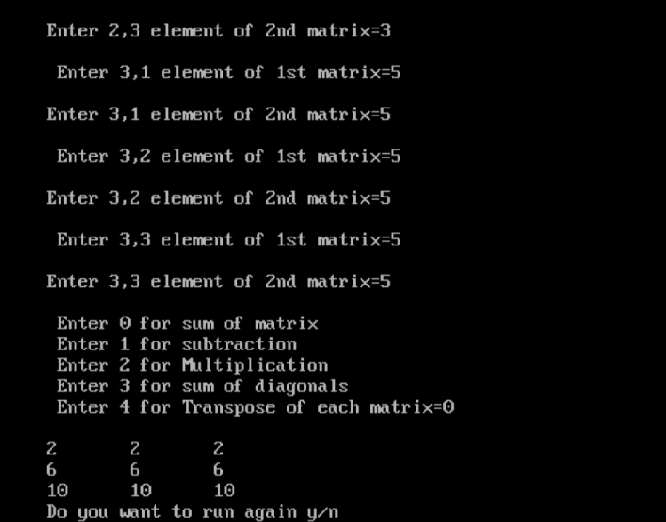

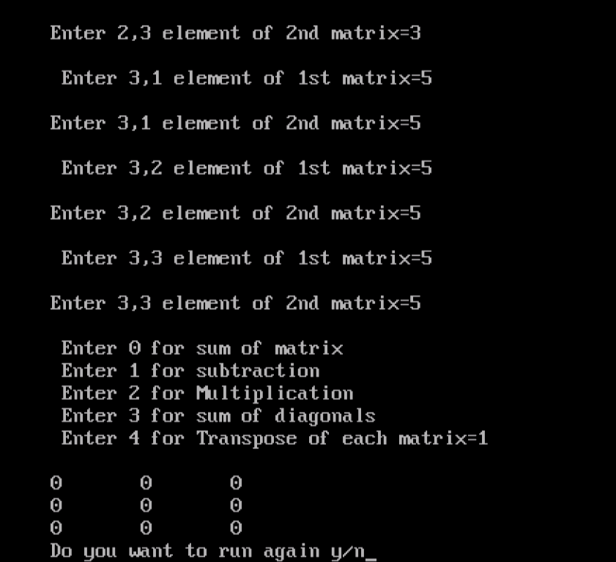 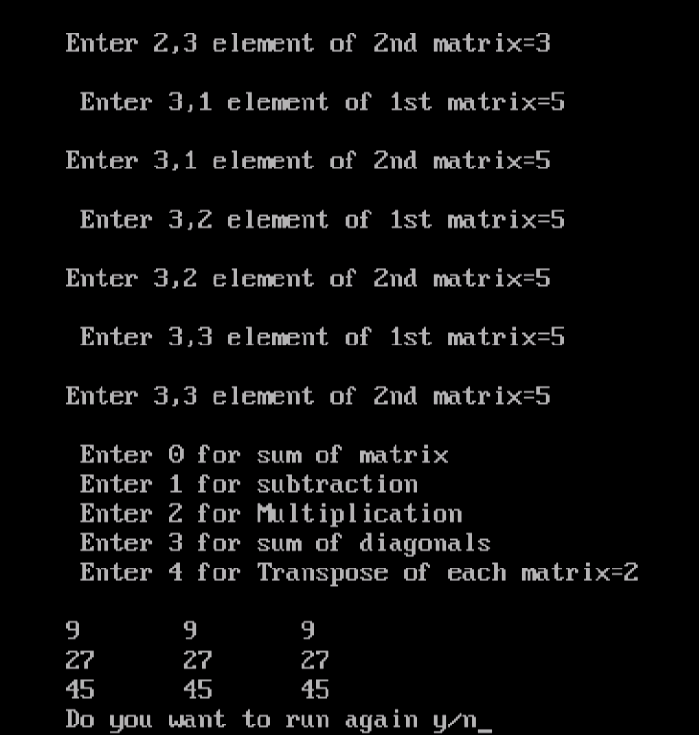

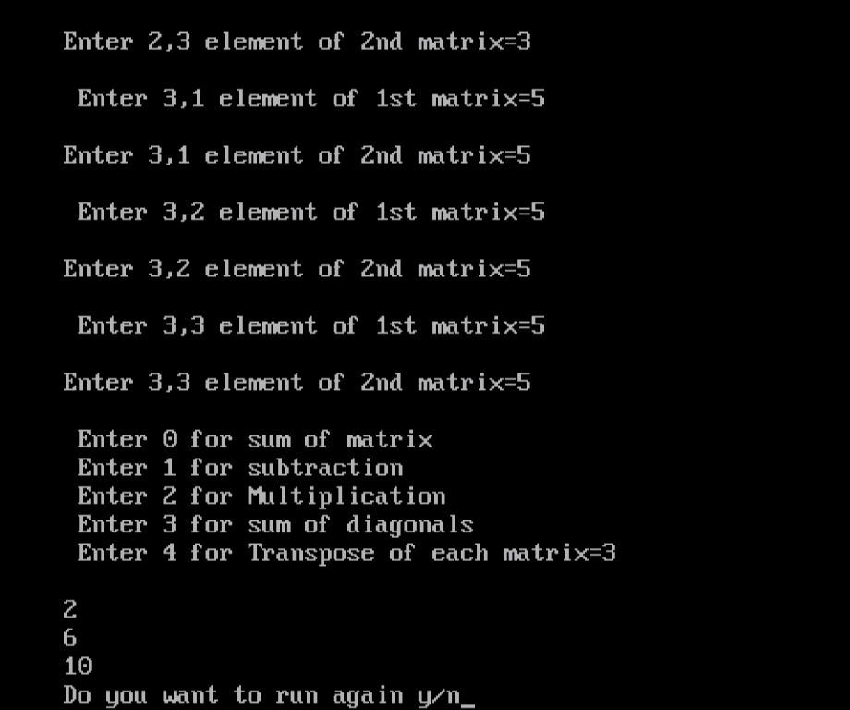 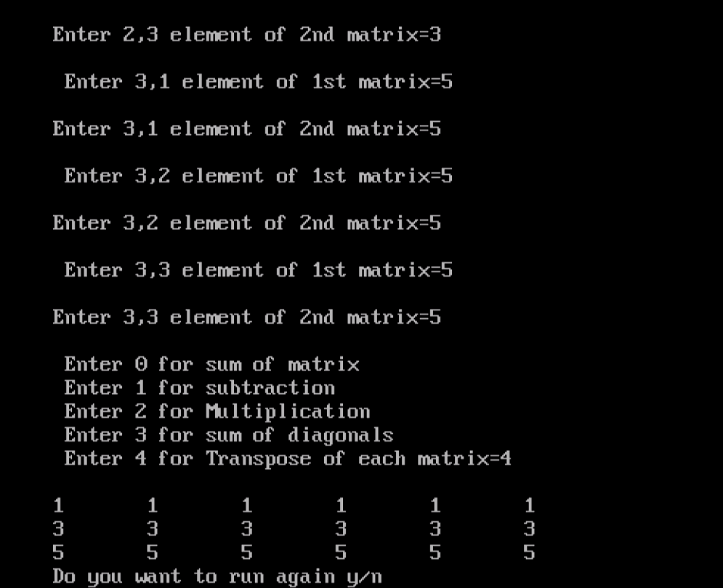

QUEST12

WAP to check whether the string is palindrome or not

#include <stdio.h>

#include <conio.h>

#include <string.h>

void main()

{

char s[1000];

int i,n,c=0;

clrscr();

printf("Enter the string : ");

gets(s);

n=strlen(s);

for(i=0;i<n/2;i++)

{

if(tolower(s[i])==tolower(s[n-i-1]))

c++;

}

if(c==i)

{

printf("%s is palindrome.",s);

}

else

{

printf("%s is not palindrome.",s);

}

getch();

}

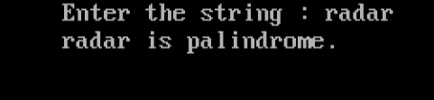

QUEST13

Read a line of lower case text and store its upper case equivalent to the data file

//from keyboard to file

#include<stdio.h>

#include<conio.h>

main()

{

FILE *fpt;

char c;

clrscr();

fpt=fopen("sample.dat","w");

do

putc(toupper(c=getchar()),fpt);

while(c!='\n');

fclose(fpt);

}



QUEST14

Read a line of text from a data file and display it on the screen

//form file of monitor

main()

{

FILE *fpt;

char c;

if((fpt=fopen("sample.dat","r"))==NULL)

printf("file don't exists");

else

do

putchar(c=getc(fpt));

while(c!='\n');

fclose(fpt);

}

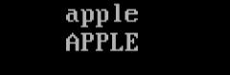

QUES15

Read the contents of a file and copy it to another file char by char.

//To read the content of a file and copy it to a different file char by char

#include<stdio.h>

#include<conio.h>

void main()

{FILE *fs,*ft;

char ch;

clrscr();

fs=fopen("sample.txt","r");

if(fs==NULL)

{ puts("cannot open the source file");

exit();

}

ft=fopen("naming.txt","w");

if(ft==NULL)

{

puts("cannot open target file");

fclose(ft);

exit();

}

do

{ch=fgetc(fs);

fputc(ch,ft);}

while(ch!=EOF);

fclose(fs);

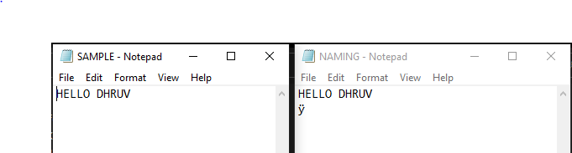fclose(ft);

}

QUEST 16

WAP to swap the number by call by reference

#include <stdio.h>

#include <conio.h>

swap (int *a,int *b)

{

*a=*a+*b;

*b=*a-*b;

*a=*a-*b;

}

void main()

{

int a, b;

clrscr();

printf("Enter value of a : ");

scanf("%d", &a);

printf("Enter value of b : ");

scanf("%d", &b);

printf("Before Swapping:\n");

printf("a = %d,b = %d\n", a, b);

swap(&a, &b);

printf("After Swapping:\n");

printf("a = %d,b = %d", a, b);

getch();

}

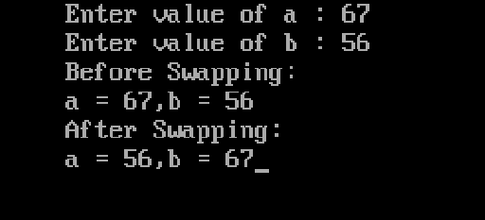

QUEST 17

WAP to swap the number by call by values

#include <stdio.h>

#include <conio.h>

void swap (int a, int b)

{

a=a+b;

b=a-b;

a=a-b;

printf("After swap: a=%d, b=%d.",a,b);

}

void main()

{

int a,b;

clrscr();

printf("Enter a = ");

scanf("%d",&a);

printf("Enter b = ");

scanf("%d",&b);

printf("Before swap: a=%d,b=%d.\n",a,b);

swap(a,b);

getch();

}

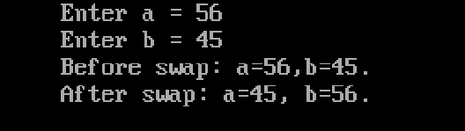

QUEST 18

WAP to print Fibonacci series using recursion

#include<stdio.h>

#include<conio.h>

f(int n)

{

if (n==1)

{

return 0;

}

else if (n==2)

{

return 1;

}

else

{

return (f(n-1)+f(n-2));

}

}

void main()

{

int i,n;

printf("Enter number of lines of Fibonacci series your want to print : ");

scanf("%d",&n);

printf("The Fibonacci series of %d lines is : \n",n);

for (i=1;i<=n;i++)

{

printf("%d\n",f(i));

}

}

